SIMATS ENGINEERING
ASSESSMENT TOOL 1

COURSE NAME: Design and Analysis of Algorithms COURSE CODE: CSA06

COURSE OUTCOME COVERED

CO3: Design Divide and Conquer algorithms for Merge Sort, Quick Sort, Binary Search and Matrix Multiplication (BL4, BL5)

Annexure A

21.Analyze the impact of parallel merge operations in Merge Sort by implementing multi-threaded merging for large datasets. Record execution time for varying numbers of threads. Interpret how parallelism improves performance and identify bottlenecks. Justify the scalability of Merge Sort in parallel environments.

Experiment No: 21

Title:
Analyze the Impact of Parallel Merge Operations in Merge Sort using Multi-Threading

Aim
To analyze the impact of parallel merge operations in Merge Sort by implementing multi-threaded merging for large datasets and comparing the execution time for different numbers of threads.

Objective:
- To implement Merge Sort using multiple threads.
- To measure execution time for different thread counts.
- To analyze the performance improvement achieved through parallelism.
- To identify bottlenecks in parallel execution.
- To justify the scalability of Merge Sort in parallel environments.

Theory:
Merge Sort is a Divide and Conquer algorithm that divides the input array into smaller subarrays until each subarray contains only one element. The subarrays are then merged in sorted order to obtain the final sorted array.
In parallel Merge Sort, multiple threads are used to sort different parts of the array simultaneously. Since different threads work independently, the total execution time can be reduced on multi-core processors. However, synchronization and thread creation introduce additional overhead.

Algorithm:
- Read or generate a large dataset.
- Divide the array into two or more parts.
- Assign each part to a separate thread.
- Each thread performs Merge Sort independently.
- Wait for all threads to complete execution.
- Merge the sorted subarrays.
- Measure the execution time.
- Compare the execution time for different thread counts.
- Analyze the results and identify bottlenecks.

Flowchart
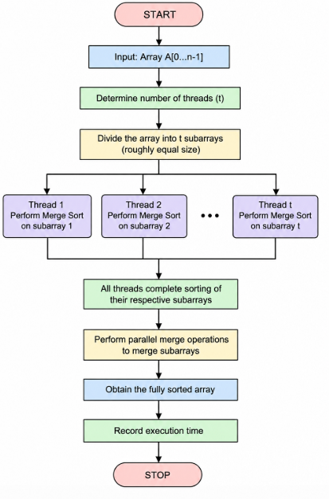
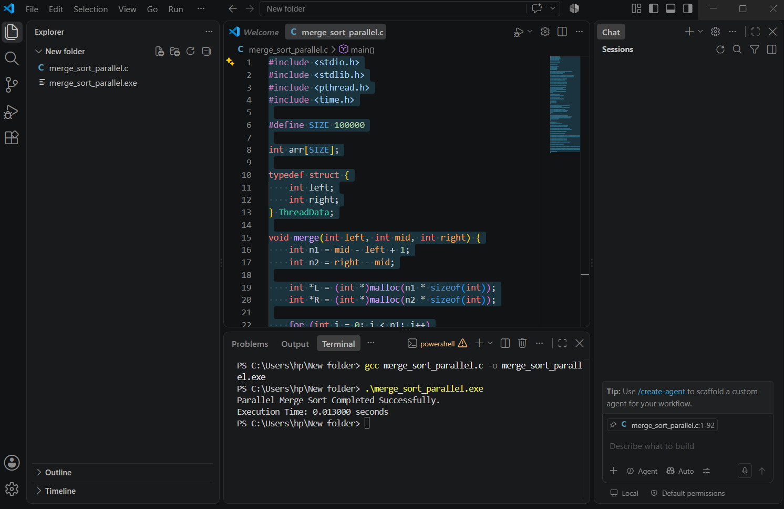

RUBRICS FOR CALCULATION

Experiments
Criteria | Weightage | Level 4 – Exemplary | Level 3 – Proficient | Level 2 – Developing | Level 1 – Beginning
Understanding of Concepts | 25 | Demonstrates thorough understanding and effectively integrates multiple concepts/technologies | Good understanding with proper integration of most concepts | Basic understanding; limited or partial integration | Poor understanding; unable to integrate concepts
Experimental Design | 30 | Well-planned, systematic implementation with optimal solution | Correct implementation with minor issues | Basic implementation with errors or inefficiencies | Incorrect or incomplete implementation
Use of Tools | 20 | Effective and advanced use of tools/technologies with proper configuration | Appropriate use of tools with correct execution | Limited or inconsistent use of tools | Incorrect or minimal use of tools
Analysis of Results | 15 | Insightful analysis with accurate interpretation and validation of results | Good analysis with reasonable interpretation | Basic analysis with limited insights | Poor or incorrect analysis of results
Documentation | 10 | Clear, well-structured documentation with diagrams, code, and results | Organized documentation with necessary details | Basic documentation with missing details | Poor or incomplete documentation

